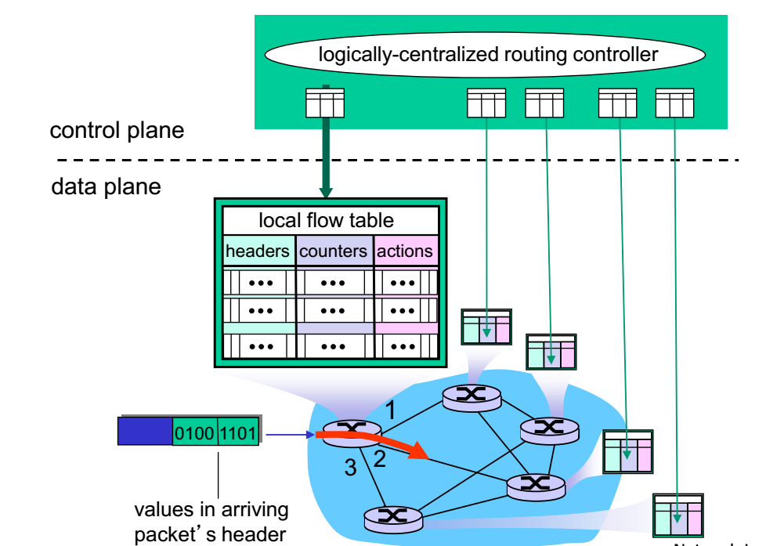

**Openflow data plane abstraction**

flow:defined by header fields

generalized forwarding: simple packet-handling rules

Pattern: match values in packet header fields

Actions: for matched packet: drop, forward, modify, matched packet or send matched packet to controller

Priority: disambiguate overlapping patterns

Counters: #bytes and #packets

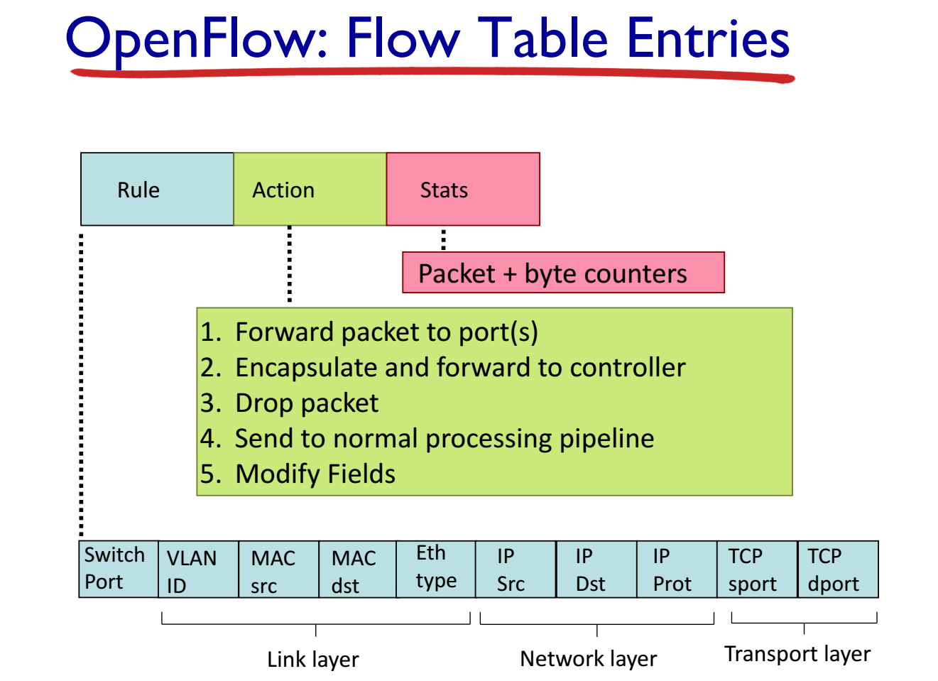

**OpenFlow abstraction**

**Router**

match: longest destination IP prefix

action: forward out a link

**Switch**

match: destination MAC address

action: forward or flood

**Firewall**

match: IP addresses and TCP/UDP port numbers

action: permit or deny

**NAT**

match: IP address and port

action: rewrite address and port

